**Docker swarm**

1. **Ec2 instances in aws console**

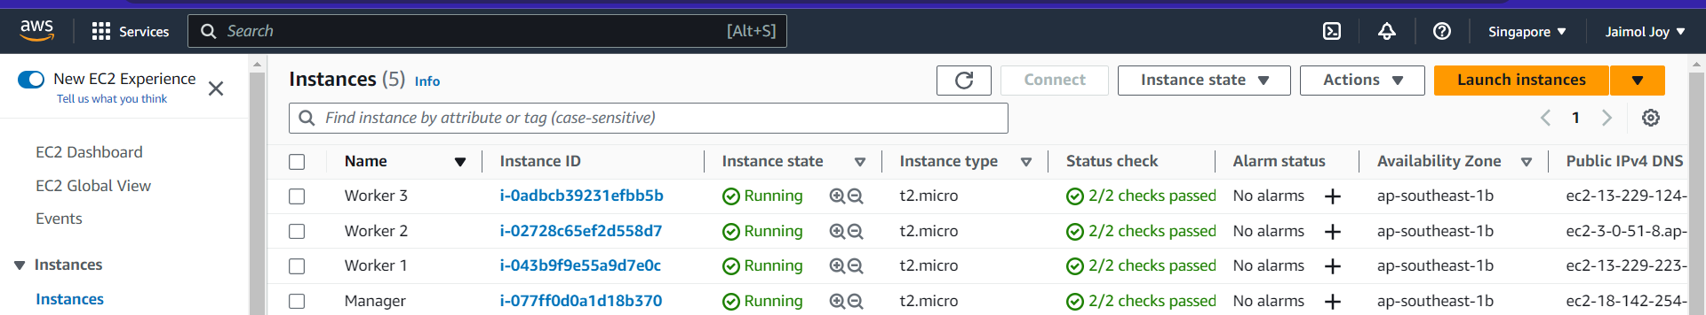

1. **Manager node update and docker installation**

**apt update –y**

**apt install docker.io –y**

**which docker**

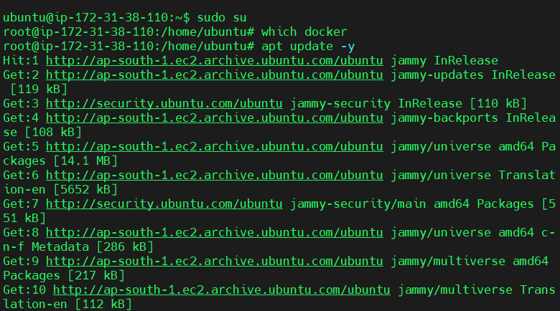

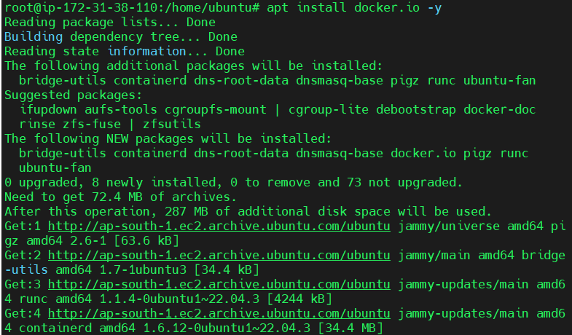

1. **Node assigned as manager**

**docker swarm init**

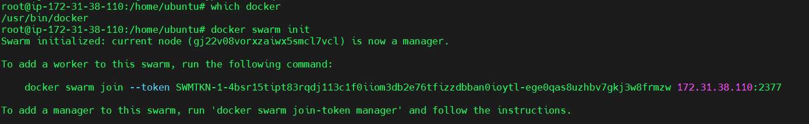

1. **Worker nodes added**

**docker swarm join --token SWMTKN-1-4bsr15tipt83rqdj113c1f0iiom3db2e76tfizzdbban0ioytl-ege0qas8uzhbv7gkj3w8frmzw 172.31.38.110:2377**



1. **docker node ls**

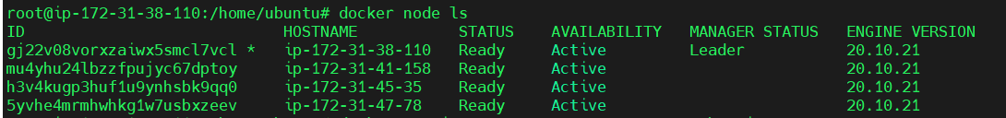

1. **Creation of service named web**

**docker service create -p 80:80 - -name web nginx**

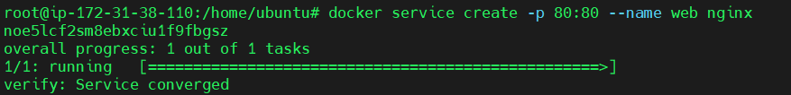

1. **docker service ps web**



1. **docker ps**



1. **Scaling the service to 2**

**docker service scale web=2**

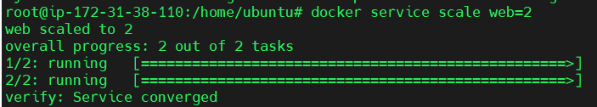

1. **docker service ps web**



1. **docker ps**



1. **Removing the service**

**docker service rm web**



1. **Creation of service named website**

**docker service create -p 80:80 - -name website - -mode global nginx**

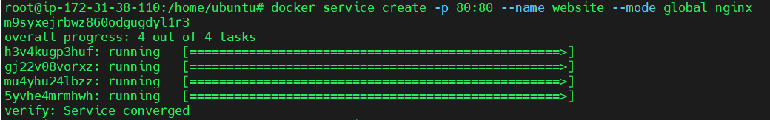

1. **docker service ls**



1. **docker service ps website**



1. **docker ps**







1. **Removing the service**

**docker service rm web**



1. **docker service create –p 80:80 - -name website - - replicas 3 nginx**

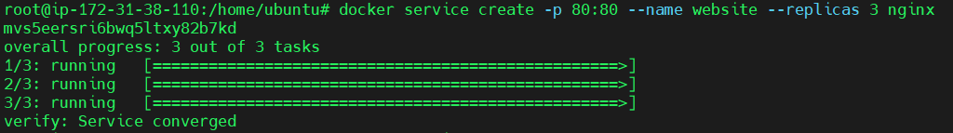

1. **docker service ps website**

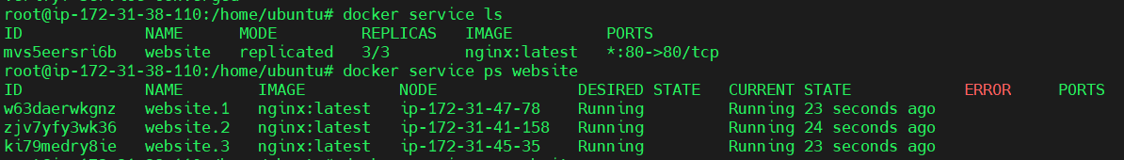

1. **docker ps**







1. **docker service rm website**

